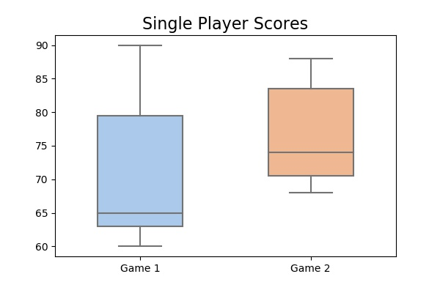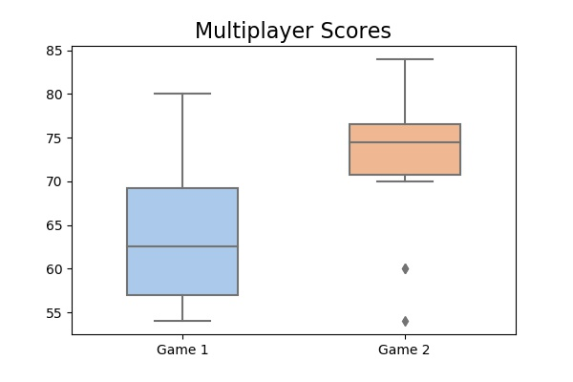

Figure . Participant scores in the Single Player and Multiplayer paradigms. For Single Player, there is no significant change in performance between games 1 and 2 (p value = 0.108). n = 11. For Multiplayer, there is a significant improvement in performance in Game 2 (p value = 0.00371). n = 16. While the mean score in the Single Player paradigm is higher than in the Multiplayer for Game 1 and Game 2, this is not statistically significant. This may be due to the small sample size, especially in the Single Player paradigm.

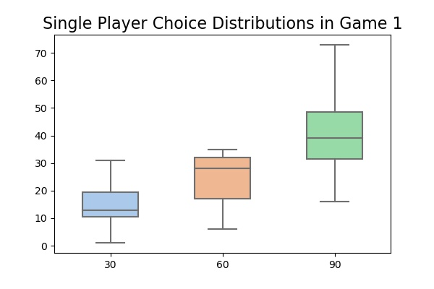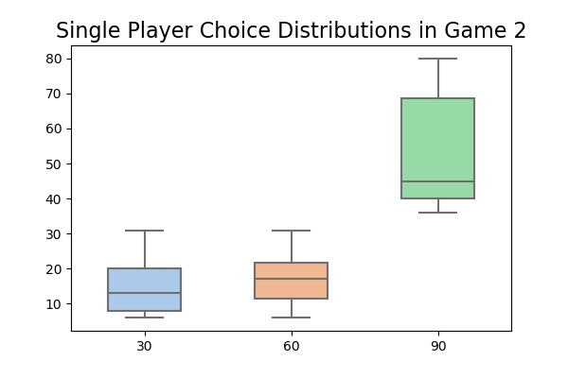

Figure 2. Choice distributions in the Single Player paradigm, in Game 1 and Game 2. No significant change in the number of times that hole 30 and hole 60 are chosen (p value = 0.147 and 0.122). n = 11

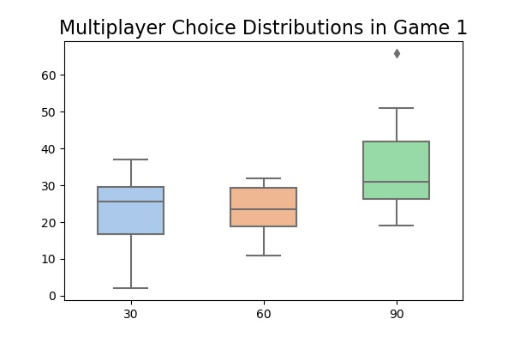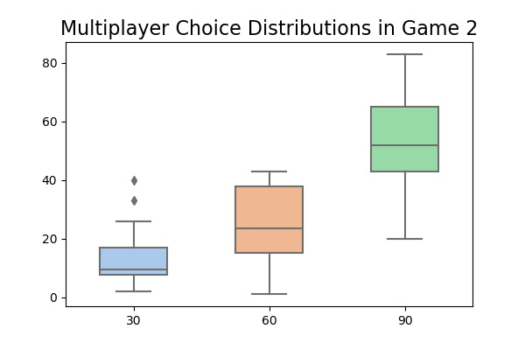

Figure 3. Choice distributions in the Multiplayer paradigm, in Game 1 and Game 2. There is a significant change in the number of times that hole 30 is chosen (p value = 0.0198), but not the number of times that hole 60 is chosen ( p value = 0.910). n = 16.

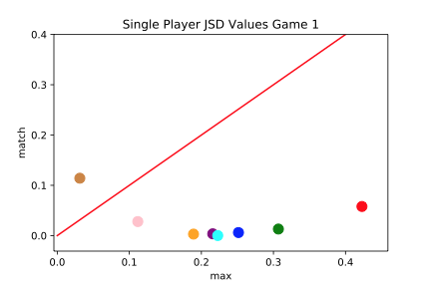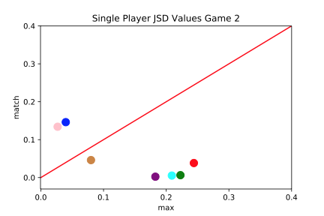

Figure 4. JSD values for maximizing and matching in the Single Player paradigm, for Game 1 and Game 2. Each dot corresponds to a subject. A red line of slope one is plotted for reference. Subjects under the red line had choice distributions closer to that of a matching strategy, while subjects above the red line had choice distributions closer to that of a maximizing strategy. In Game 2, participants used a more maximizing strategy (p value = 0.0608). n = 11.



Figure 5. JSD values for maximizing and matching in the Multiplayer paradigm, for Game 1 and Game 2. Each dot corresponds to a subject. A red line of slope one is plotted for reference. Subjects under the red line had choice distributions closer to that of a matching strategy, while subjects above the red line had choice distributions closer to that of a maximizing strategy. In Game 2, participants used a more maximizing strategy (p value = 0.0160). n = 11.